**Basic Progress Bar**

A progress bar can be used to show how far a user is in a process.

**Example :**

<div class="container mt-3">

<h2>Basic Progress Bar</h2>

<p>To create a default progress bar, add a .progress class to a container element and add the progress-bar class to its child element. Use the CSS width property to set the width of the progress bar:</p>

<div class="progress">

<div class="progress-bar" style="width:70%"></div>

</div>

</div>

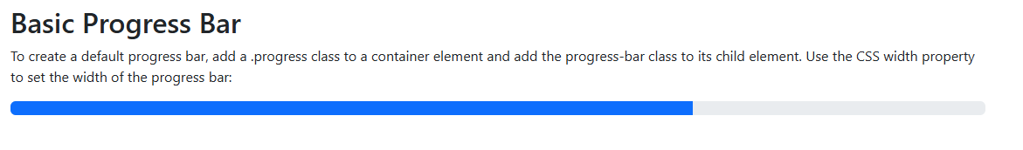

**Progress Bar Labels**

Add text inside the progress bar to show the visible percentage:

<div class="progress">  
  <div class="progress-bar" style="width:70%">70%</div>  
</div>



**Colored Progress Bars**

**Example :**

<!-- Blue -->  
<div class="progress">  
  <div class="progress-bar" style="width:10%"></div>  
</div>  
  
<!-- Green -->  
<div class="progress">  
  <div class="progress-bar bg-success" style="width:20%"></div>  
</div>  
  
<!-- Turquoise -->  
<div class="progress">  
  <div class="progress-bar bg-info" style="width:30%"></div>  
</div>  
  
<!-- Orange -->  
<div class="progress">  
   <div class="progress-bar bg-warning" style="width:40%"></div>  
</div>  
  
<!-- Red -->  
<div class="progress">  
  <div class="progress-bar bg-danger" style="width:50%"></div>  
</div>  
  
<!-- White -->  
<div class="progress border">  
  <div class="progress-bar bg-white" style="width:60%"></div>  
</div>  
  
<!-- Grey -->  
<div class="progress">  
  <div class="progress-bar bg-secondary" style="width:70%"></div>  
</div>  
  
<!-- Light Grey -->  
<div class="progress border">  
  <div class="progress-bar bg-light" style="width:80%"></div>  
</div>  
  
<!-- Dark Grey -->  
<div class="progress">  
  <div class="progress-bar bg-dark" style="width:90%"></div>  
</div>